2014 HKEA Eighth Biennial Conference
December 13-14, 2014, Shandong University, Jinan, China
Hotel Accommodation Registration Form
Please email or fax the completed registration form with to Hong Kong Economic Association on or before 15 October 2014.

Email: economic@ln.edu.hk Fax: (852) 2891 7940 Enquiries: (852) 2616 7381

Hotel Accommodation
Participants are recommended to stay at the University Hotel or the Jinan NSHT Hotel. HKEA will book the room for you prior to the conference. Payment can be made by yourself when you check out after the conference.

- University Hotel (website: http://www.unihotel.com.cn/xueren/index.asp)

Situation:
University Hotel (Xueren), a three-star hotel, is situated in the central campus of Shandong University (27 Shanda Nanlu, Jinan, Shandong Province, P.R.China), which is very close to the conference hall.

Price:
- Single Room: 328RMB per day
Facilities: double-bed, central air-conditioning, DDD/IDD telephone, mini-bar, WIFI, high-speed internet access and satellite TV

- Standard Room: 328RMB per day
Facilities: two single beds, central air-conditioning, DDD/IDD telephone, mini-bar, WIFI, high-speed internet access and satellite TV.

- Jinan NSHT Hotel (website: http://www.cnnish.com/jnnishi/channels/97.html)

Situation:
Jinan NSHT Hotel (Ni Shi Hai Tai, NSHT), a five-star standardized hotel, is situated in the middle of east ring road of Jinan (3690 Erhuan Donglu, Jinan, Shandong Province, P.R.China), which is within 20-minute walking distance from conference hall in the central campus of Shandong University.

Price:
- Single Room: 428RMB per day
Facilities: double-bed, central air-conditioning, DDD/IDD telephone, mini-bar, WIFI, high-speed internet access, satellite TV and etc.

- Standard Room: 428RMB per day
Facilities: two single beds, central air-conditioning, DDD/IDD telephone, mini-bar, WIFI, high-speed internet access, satellite TV and etc.

Note: Above is the current price for reference. Fees may fluctuate with low and high seasons.

Map

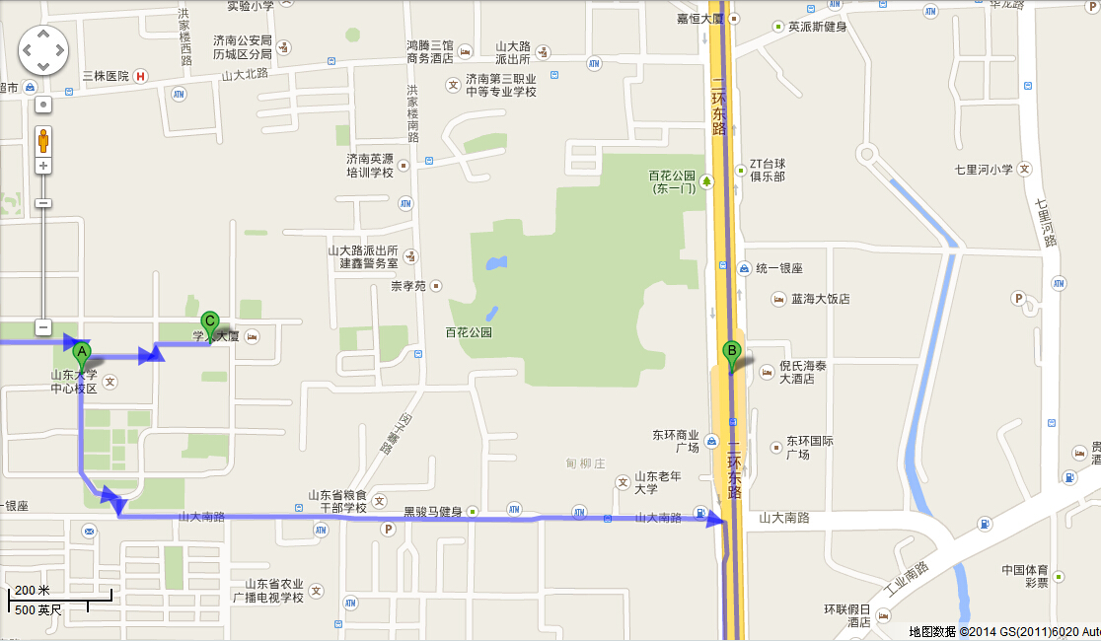

Site A: Shandong University, Central Campus
Site B: Jinan NSHT Hotel
Site C: University Hotel

Please tick your choices and mark down the dates of stay.

Room Accommodation Registration Form

Guest name: Mr./Mrs./Miss (Surname) (name)
Tel No.: | Fax No.: |  |  |  |  |  |  | Email:
Hotel: | University Hotel |  |  |  |  |  |  | Jinan NSHT Hotel
Room Type:
University Hotel: |  |  | Single Room (RMB328 per day) |  |  |  |  | Standard Room (RMB328 per day)
Jinan NSHT Hotel: |  |  | Single Room (RMB428 per day) |  |  |  |  | Standard Room (RMB428 per day)
Room Preference: (subject to availability) |  |  |  |  |  | Smoking |  |  |  | Non-Smoking
Check-in Date |  |  |  |  | Check-out Date |  |  |  |  | No. of night(s)
Total Amount Paid: |  |  |  |  |  |  |  |  |  |  | RMB

* Breakfast is included in both hotel

___________________________________________________________________________

Post-conference trip to Qufu (15 December 2014):

We will also organize a post-conference trip to Qufu, the hometown of Confucius, on 15 December, 2014 (departure by bus at about 9:00am and returning to your hotel at 6:00pm). Please let us know if you will join the trip. The (subsidized) charge is RMB200 per person which covers bus fair, all entry tickets to the Mansion, Temple, and Cemetery of Confucius, and lunch. The payment should be paid on site.

Please tick your choices.

I will join the tour with _________ guest(s).

Total payment: ______________ (RMB200 per person)

I will not join the tour.

